P234

2、

#include<iostream>

using namespace std;

struct student

{ char name[20];

unsigned int id;

double score;

void input()

{cout<<"name?";

cin>>name;

cout<<"id?";

cin>>id;

cout<<"score?";

cin>>score;

}

void output()

{cout<<"name:"<<name<<"\tid:"<<id<<"\tscore:"<<score<<endl;}

} ;

int main()

{ student s;

s.input();

s.output();

}

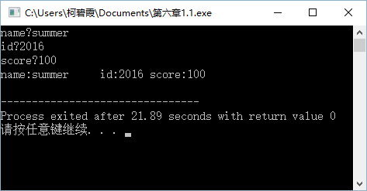

P242

1、

#include<iostream>

using namespace std;

class book

{ public:

void display();

void borrow();

void restore();

char bookname[20];

double price;

int number;

};

void book::display()

{cout<<"书名:"<<bookname<<endl;

cout<<"价格:"<<price<<endl;

cout<<"数量:"<<number<<endl;

};

void book::borrow()

{

int m;

cout<<"借去的书的数量:";

cin>>m;

number=number-m;

cout<<"现存的书的数量:"<<number<<endl;

};

void book::restore()

{ int n;

cout<<"归还的书的数量:";

cin>>n;

number=number+n;

cout<<"现存的书的数量:"<<number<<endl;

};

int main()

{ book a;

cout<<"请输入书名:";

cin>>a.bookname;

cout<<"请输入价格:";

cin>>a.price;

cout<<"请输入数量:";

cin>>a.number;

a.display();

a.borrow();

a.restore();

}

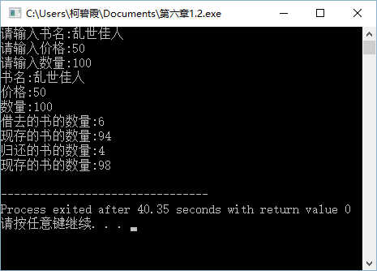

P242、

3、

#include<iostream>

using namespace std;

class student

{ public:

void scoretotalcount(double);

double sum();

double average();

private:

double score;

static double total;

static int count;

} ;

void student::scoretotalcount(double s)

{ score=s;

total=total+score;

count=count+1;

};

double student::sum()

{return total;};

double student::average()

{return total/count;};

double student::total=0;

int student::count=0;

int main()

{ int n;

double s;

student a;

cout<<"请输入学生数量：";

cin>>n;

for(int i=1;i<=n;i++)

{ cout<<"请输入第"<<i<<"位学生的成绩：";

cin>>s;

a.scoretotalcount(s);

}

cout<<"全部同学的总分："<<a.sum()<<endl;

cout<<"全部同学的平均分："<<a.average()<<endl;

}

